Final Report

Project Title: Interpret - Measuring the Impact of Risk Definitions on Disaster Vulnerability Rankings

Team Members: Evelyn Reyes, Broden Dean, Grant Helkenn, and Ronan Parks

Course: CIVE 202 – Civil Engineering Analysis II

Date Submitted for Review: 4/22/2025

Project #4

Introduction:

The U.S. faces an increasing demand for precise and fair risk assessment tools that measure natural disaster vulnerabilities within American communities. The National Risk Index developed by FEMA serves as a common tool for national vulnerability assessment but experts question how the methodology accounts for risk definition and measurement during evaluations between states and counties. Our group evaluated the National Risk Index standardized approach through a risk framework assessment in addition to testing our drought and cold wave hazard risk model. The research examined Nebraska and New York as case study states to assess how directed vulnerability measures would alter the community vulnerability rankings. The research involved Risk Averse, LLC as an independent risk analysis organization dedicated to ensuring equitable disaster planning support through allocation of funds.

Methodology:

Our analytic process started with cleaning data obtained from FEMA National Risk Index records of Nebraska and Wyoming using Python. Standardization procedures included field removal and data formatting consistency resolution and naming convention standardization for dataset interoperability purposes. Using the definitions we refined how our alternative risk model matched FEMA’s original scoring methods and established a basis for our alternative risk model's logic. The first step of our analysis involved the collection and import of FEMA NRI data together with CDC SVI data for Nebraska and Wyoming through Python programming. The analyzed datasets underwent integration with their matching STCNTY FIPS code to establish uniform Census Tract profiles for all states. Linkage between hazard-based information in the NRI and social vulnerability measures in the SVI was possible through this merge process.

After handling missing data we employed a median imputation strategy for data replacement. The pandas library within Python implemented a process to detect NA values then substituted them with the median figures of each column.

We operated using Python pandas alongside numpy libraries to execute null value checks with the .isna() function throughout our imported datasets. Our analysis of the Nebraska-specific dataset (NRI_Table_CensusTracts_Nebraska.csv) established missing data points through the implementation of Ne_nri.isna().

After this we generated specialized risk evaluation scores pertaining to drought and cold waves. The new risk calculation consisted of multiplying annual hazard frequencies DRGT_AFREQ and CWAV_AFREQ with total land area measurements LNDS_EALT within each tract. The custom risk metrics obtained through the following calculation:

* **Drought Risk** = DRGT_AFREQ × LNDS_EALT
* **Cold Wave Risk** = CWAV_AFREQ × LNDS_EALT

By integrating the CDC Social Vulnerability Index analytics we obtained Census-tract data about age distribution and income alongside disability status and housing quality breakdown. The combination of SVI data and NRI information enabled deeper understanding of community sensitivity together with resilience evaluation. The augmented dataset enabled us to create risk scores that precisely fit our two specific hazards of drought and cold wave.

Our new assessment model used four specific elements of Hazard, Exposure, Vulnerability and Response Capacity to align with FEMA's risk assessment system while concentrating on regional effects. Drought risk evaluation included priorities such as irrigation dependence and agricultural exposure together with groundwater usage. The U.S. Drought Monitor (2024) identifies drought as an active menace for Nebraska because it damages agricultural production and creates demanding pressures on water management systems. The assessment of cold wave hazard included both historic temperature lows and duration but the exposure and vulnerability levels were determined through studying older populations and lack of insulation and restricted heating access. The National Centers for Environmental Information (NOAA NCEI, 2023) indicate that cold waves continue to be recurrent dangerous events throughout Wyoming and western Nebraska which result in hypothermia and livestock deaths together with power outages.

Results:

The new risk metrics enabled assessment of changes in rankings against FEMA's composite risk scores. We utilized matplotlib and seaborn to display the modifications in rankings throughout Census Tracts across both states. Multiple rural Nebraska territories and central Wyoming geographic areas received better hazard-specific rankings through the integration of bar charts and heatmaps.

Nebraska agricultural regions received significant rankings elevations through the custom drought risk evaluation with increased occurrence of drought events. Census Tracts in western and central Wyoming having larger land areas together with more frequent cold waves demonstrated increased cold wave risk values. The composite risk score used by FEMA fails to identify essential vulnerabilities that individual hazards might reveal.

The summary tables presented data to determine which tracts experienced the largest percentile variations. States with land-based hazard prevalence require specific hazard metric assessments monitoring due to their geographical exposure features.

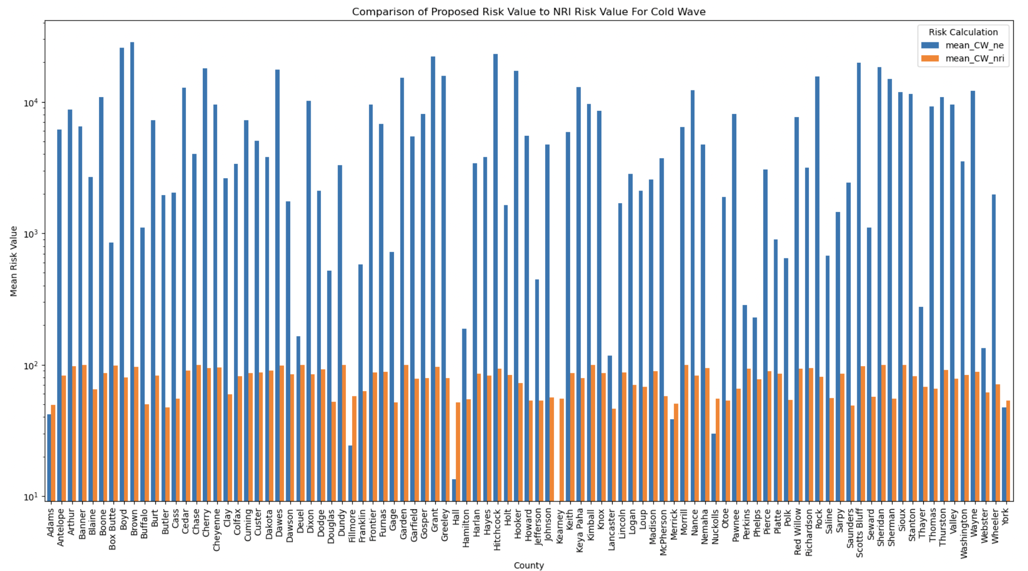

Our first graph included the Mean Risk Value of Cold Wave from both our proposed metric and the NRI data per county in Nebraska. As seen from the graph our proposed risk metric resulted in a much higher risk factor than the NRI data supplied.

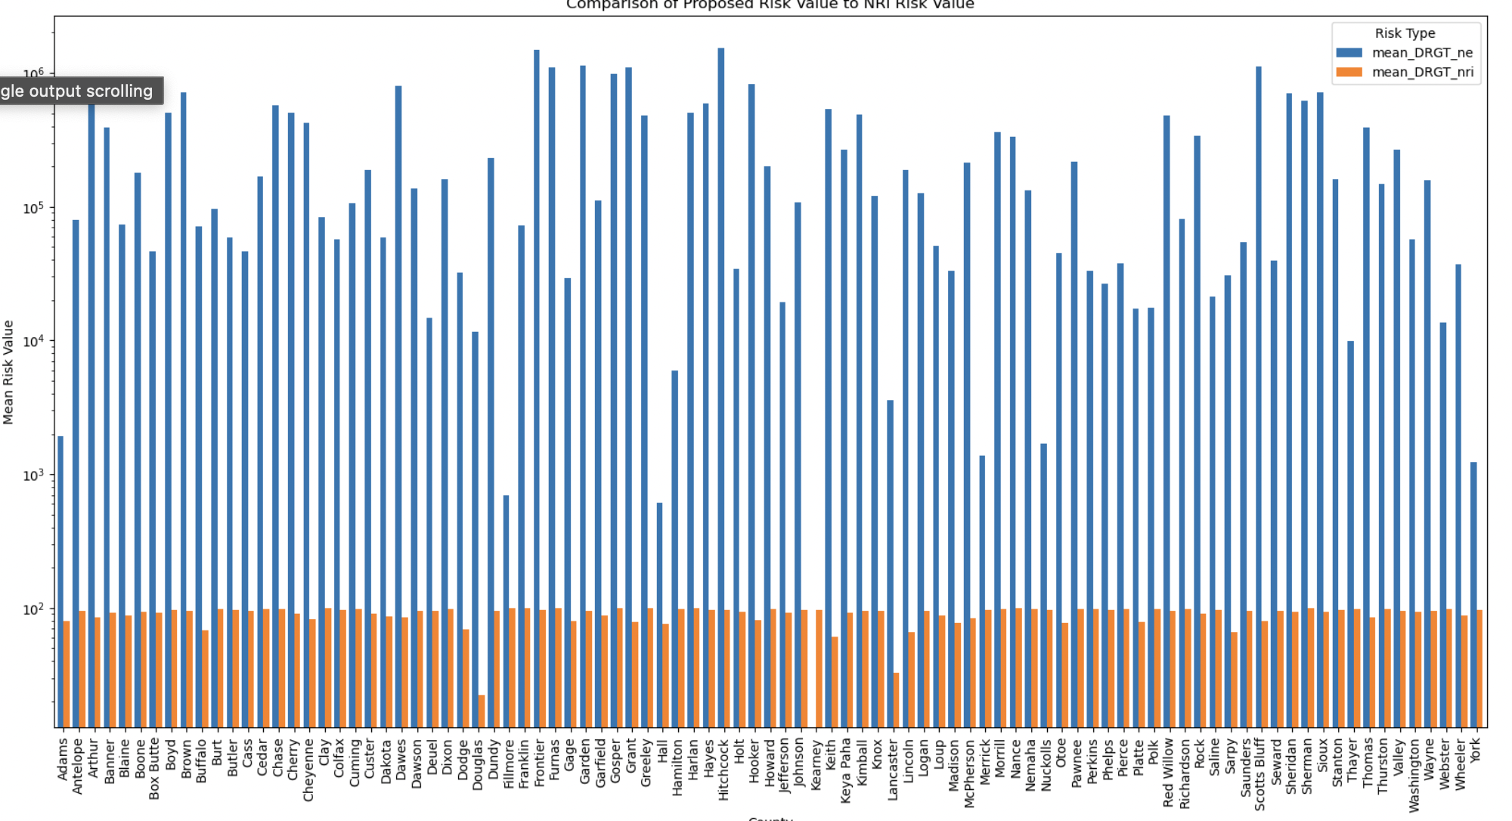

Our second graph compared our proposed risk value to the NRI data due to Droughts. This data shows the differences in our proposed risk vs the actual risk per county in Nebraska.

After looking at our Nebraska Data we moved onto the Wyoming Dataset repeating the process.

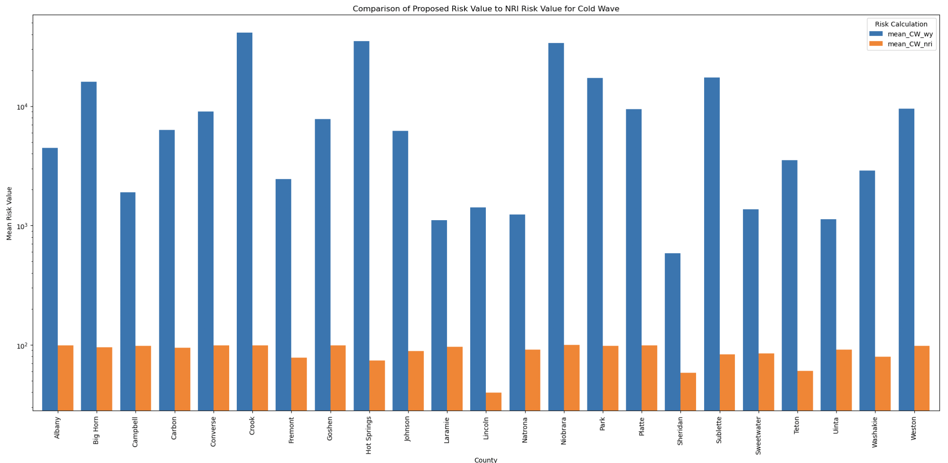

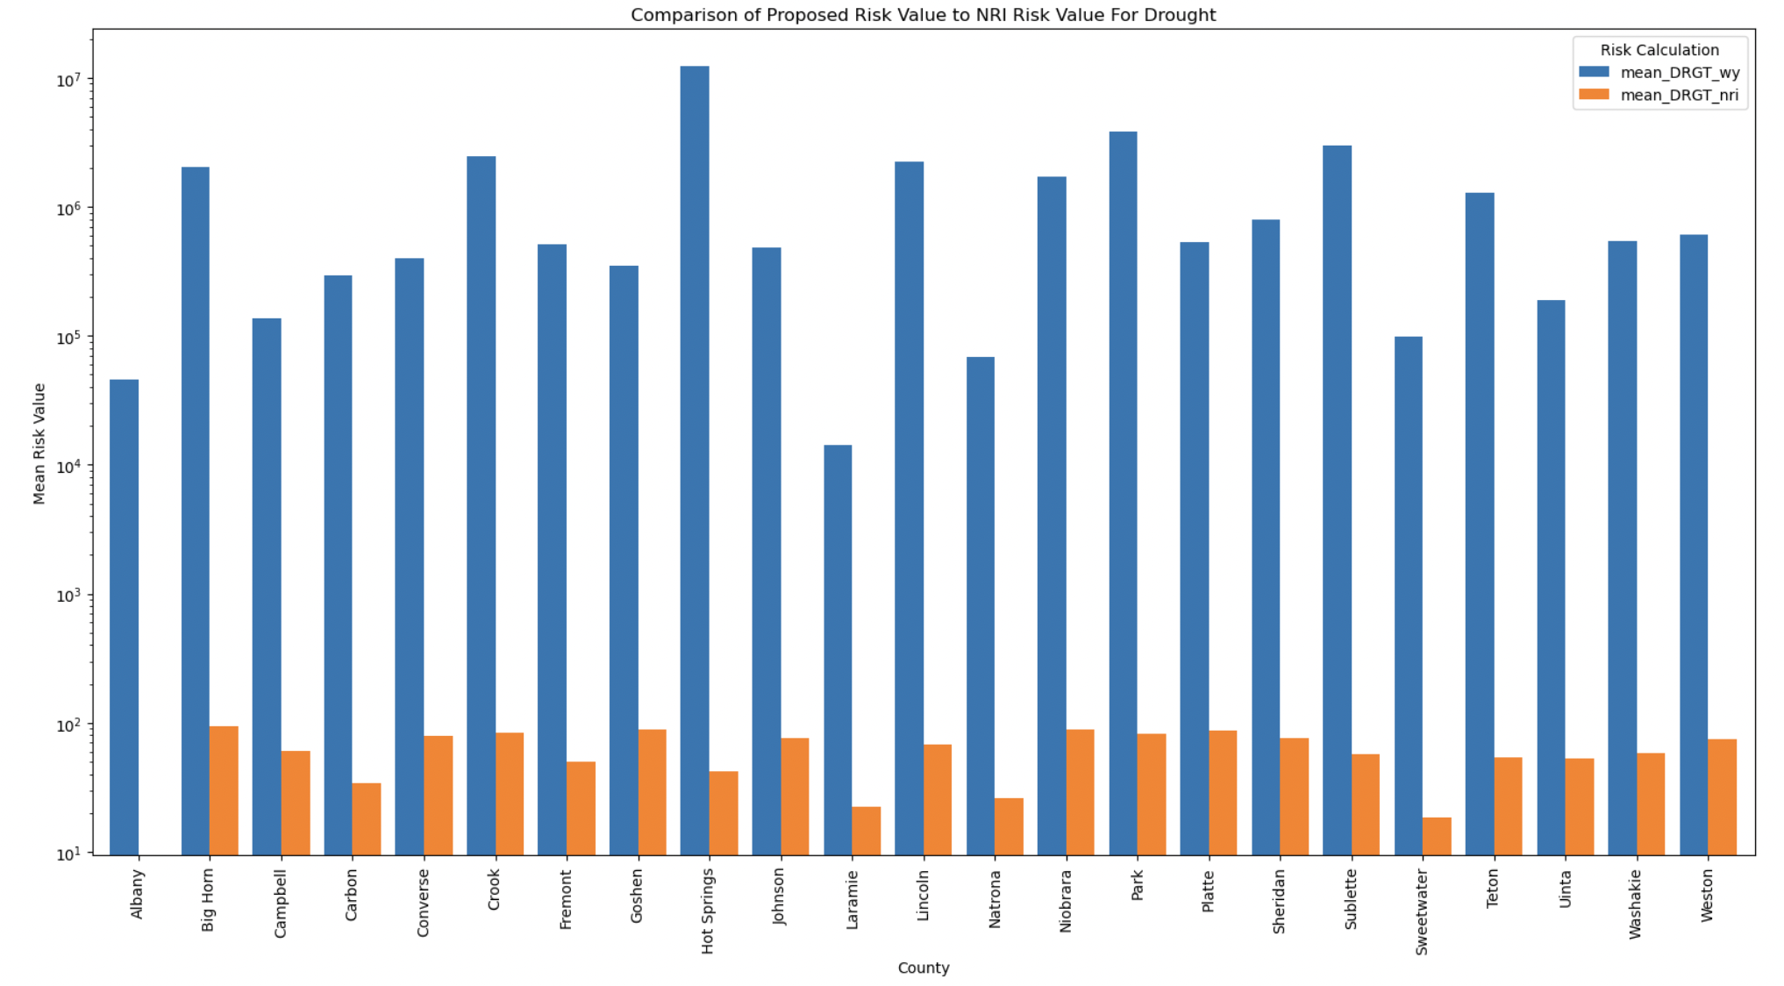

Analysis and Discussion:

The research results challenge the existence of possible biases which might appear in standardized risk models controlled by the federal government. The NRI from FEMA delivers an extensive analysis of hazard susceptibilities although it frequently fails to recognize area-specific vulnerabilities mainly in distant rural places and disadvantaged locations.

Social vulnerability data from SVI enabled researchers to confirm population risks in their relationship with environmental exposure. The combination of elderly people and inadequate heating systems in certain Census Tracts matched high cold wave scores whereas drought conditions accumulated in irrigated Nebraska farm areas. The observed patterns prove that the customized risk assessment methodology we developed is appropriate.

We discovered that the FEMA composite index fails to demonstrate jurisdictional risks which create serious damage in specific locations. The model allows us awareness regarding localized hazard conditions that enables more focused response and mitigative solutions.

Conclusion and Recommendations:

Our modernized hazard-specific risk analysis creates a localized visibility into the vulnerability levels found throughout Nebraska and Wyoming. By combining exposure to land areas with hazard frequency statistics researchers can create an improved strategy that extends beyond FEMA's basic index approach which sets aside regional variances.

FEMA together with risk planning agencies should use modular risk models which include local hazard exposure metrics and feature social vulnerability profiles. When targeting becomes more accurate local communities can receive their needed mitigation resources better and with greater effectiveness.

The project proves that we must develop adaptable data-based systems using transparent fair standards for future disaster risk evaluations.